GENERAL PROGRAM GUIDELINES AND ELIGIBILITY

COMMUNITY DEVELOPMENT BLOCK GRANT PROGRAM

The Community Development Block Grant (CDBG) Program provides annual grants on a formula basis. This is a flexible program that provides communities with a wide range of unique community development needs. The goal of the CDBG Program is to develop viable urban communities by providing decent housing and a suitable living environment along with expanding economic opportunities, for persons of low and moderate incomes.

FUNDS AVAILABLE: Total estimated available for Fiscal Year 2025 is $1.3 million.

PROGRAM TERM: October 1, 2025 through September 30, 2026

APPLICATION RELEASE MEETING
There is no mandatory application release meeting. Public hearing #1 is scheduled for 3:00 p.m. on March 26, 2025 and will be broadcast live via YouTube at https://www.youtube.com/channel/UC5z4YajVK8fUW2B7UVO6Vmw/live . It will be recorded for viewing on the Planning & Community Development (P&CD) website.

GRANT APPLICATION CONSULTATION
Grant application consultation with P&CD staff will be available by appointment only April 7, 2025 – April 11, 2025, from 8:30 am to 4:00 pm, to assist applicants with determining CDBG eligibility and National Objective qualification and answering overall application development questions. A consultation appointment is required for all applicants who have not had a funded application during the past two grant cycles (FY23, FY24).

APPLICATION DEADLINE
The Lake County Office of Planning and Community Development, located at 105 Main Street, Building B, Painesville, Ohio 44077, will accept applications no later than 4:00 P.M. on May 9, 2025.

ELIGIBLE APPLICANTS
- Units of general purpose government for “balance of County” villages, municipalities, and townships. (excluding the City of Mentor and Waite Hill Village)
- Private, non-profit organizations, small business investment corporations, or community development corporations, with specific community development and/or housing programs
- Institutions of higher education
- Public Housing Authorities

ELIGIBLE ACTIVITIES
- A CDBG-funded project or program must be an eligible activity, meet a national objective, and serve a need listed in the Consolidated Plan. Types of eligible activities include acquisition/disposition, housing, public services, public improvements, economic development, and administration and planning. A more detailed list of eligible activities is available on the P&CD website.

INELIGIBLE ACTIVITIES
- Buildings or portions thereof, used for the general conduct of government
- General government expenses
- Political activities

GENERALLY INELIGIBLE ACTIVITIES
- Purchase of equipment
- Operating and maintenance expenses
- New housing construction
- Income payments

RESOURCE INFORMATION
- Rhea Benton, Assistant Director
Lake County Office of Planning and Community Development, 105 Main Street, Painesville
Rhea.Benton@lakecountyohio.gov, phone (440) 350-2740, fax (440) 350-2606
- Visit Planning & Community Development website https://www.lakecountyohio.gov/planning-community-development/ and HUD Exchange website https://www.hudexchange.info/programs/cdbg/cdbg-ta-products/#all-products

EVALUATION CRITERIA
- Meeting a need and fulfilling a goal based on the Consolidated Plan
- Application completion in its entirety
- All appropriate documentation attached
- Leverages/matches with funding from another source will receive a more favorable review
- Ability to complete project in a timely manner
- Agency capacity and project feasibility
- Other criteria as deemed necessary by the P&CD office

SIGNIFICANT APPLICATION CHANGES
- Low to Moderate Income Block Groups have changed based on the latest ACS data.
- Applicants must obtain a Unique Entity ID and a Sam.gov Registration through the website: https://sam.gov/content/entity-registration . (Please note that after grant award, any Contractors procured by Sub-grantees must also obtain a Sam.gov Registration.)
- Public Services must be new or expanded services. Public Service applicants must demonstrate that there has been a new service or an expanded service than was delivered in the 12 months prior to Lake County’s latest action plan.

APPLICATION TABLE OF CONTENTS
- Sections

Cover Page…………………………………………………………………. page 3
I. Applicant Information………………………………………………… page 4
II. Project Specific Information……………………………………….. page 5
III. Narrative Section………………………………………………………… page 7
IV. Organizational Capacity……………………………………………… page 10
V. Budget……………………………………………………………………….. page 11
VI. Schedule…………………………………………………………………….. page 12
VII. Threshold Criteria/Application Checklist…………………….. page 13
VIII. Authorization……………………………………………………………… page 13

- Appendices

A. HUD Income Limits and Block Groups Chart…………….. page 14
B. Low Income Block Group Map…………………………………… page 15
C. Census Tract Map………………………………………………………. page 16
D. AFFH & Consolidated Plan Goals……………………………….. page 17
E. Section 3 Information………………………………………………… page 18

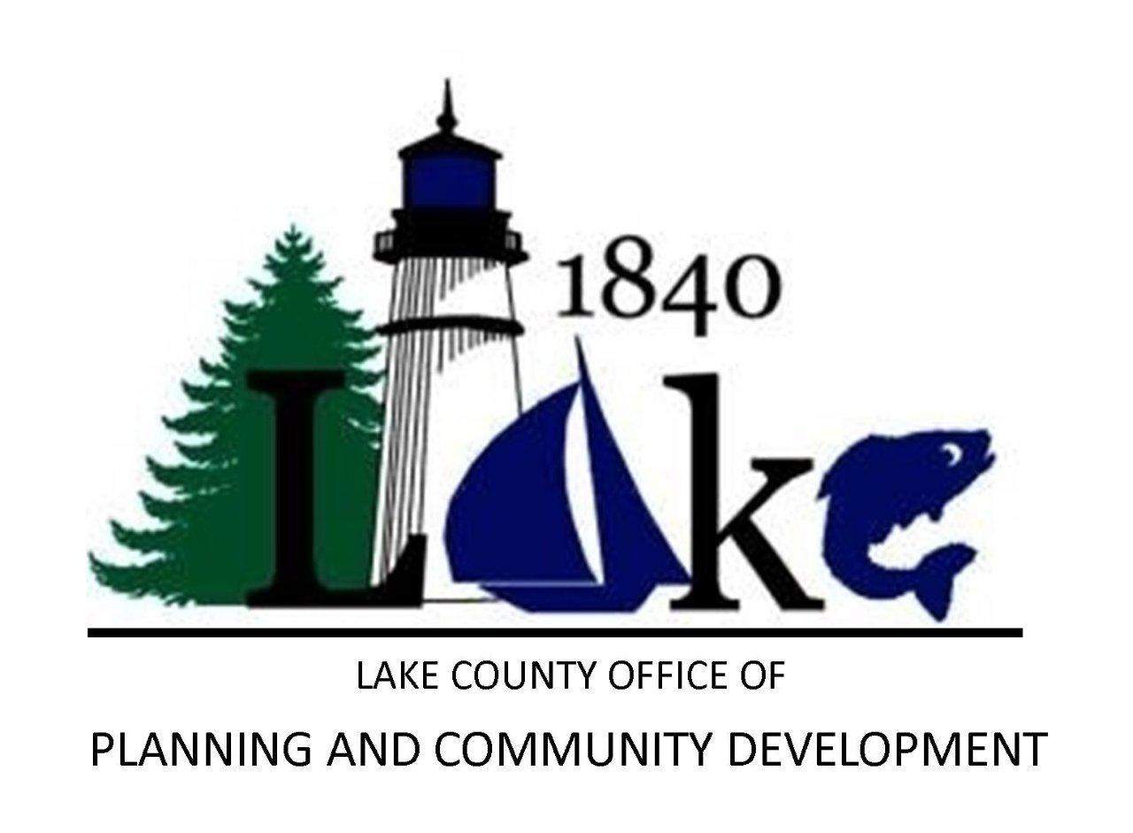

APPLICATION FORM
Competitive Community Development Block Grant Program
FY 2025 (October 1, 2025 – September 30, 2026)
Application for Assistance

Applicant Name

Proposed Project Title

I. Applicant Information

Community or Agency | Chief Executive Officer
Street Address | Direct Telephone #
City / Zip+4 | Contact Person (primary grant administrator)
Federal Tax ID # | Title
Main Telephone # | Direct Telephone #
Unique Entity ID # | E-Mail
 | Fax Number

I certify that this Community and/or agency possesses the legal authority to proceed with this project if it is awarded, a copy of the authorizing documentation is attached, that the information contained herein is true and correct and that the submittal of this application has been duly authorized.

Type Name of Chief Executive Officer: | Title:
Signature: | Date:

II. Project Specific Information

Project Title:

Project Funding Request:
Total funding requested in this application
Total cost to complete project
Project Location:
Project Address(es): | Census Tract: | Block Group:
Describe the Service Area of the Project:

Project Details
Project Category:  (Check one only) | ___Public Service | ___Capital Improvement
___Planning or Administration | ___Economic Development | ___Housing Activities

CDBG Criteria: Which CDBG criterion below does your project meet? Check One.
_____a. Area benefit: At least 50.5% of residents within  The targeted activity area are low to moderate  income (LMI), see map in Appendix B.  _____b. Limited clientele (Select subpart):  _____(1) Special needs group  _____ (i) Abused children  _____ (II) Elderly persons 62 years or older  _____ (iii) Survivors of Domestic Violence  _____ (iv) Severely disabled adults  _____ (v) Illiterate adults  _____ (vi) Persons living with HIV/AIDS  _____ (vii) Migrant Farm Workers  _____ (viii) Homeless persons  _____ (2) At least 51% of clientele to be served will be  documented as LMI. | _____c. Housing (select subpart):  _____ (a) Single family (all must be LMI)  _____ (b) Multi-unit (more than half must be LMI)  _____d. Job creation: At least 51% of jobs for LMI persons:  Number of FTE jobs to be created. ______________  _____e. Elimination of Slums and Blight (select subpart):  _____ (i) Area Basis  _____ (ii) Spot Basis  _____f. Urgent Need
Performance Measures: Complete for the category applicable to the proposed project.
________a. Proposed Number of Persons to be served or assisted (Required for all proposed Public Services activities)

________b. Proposed Number of Households to be served or assisted (Required for all proposed Housing activities)

________c. Proposed Number of Businesses to be served or assisted

________d. Proposed Number of Housing Units to be assisted

________e. Proposed Number of Public Facilities to be assisted

________f. Proposed Number of Beds in overnight shelter or emergency housing

Performance Measures Continued: Which AFFH actions below will be accomplished before the end of the program period? Check one or more.
After reviewing Appendix D – AFFH and Consolidated Plan Goals and resource materials noted therein, select at least one of the Affirmatively Furthering Fair Housing actions shown below for which your agency / community will report accomplishments during the reporting period (10/1/25 – 9/30/26).

______ a. *Develop fair housing knowledge base at your agency / community through attendance at training – this can be an online training. Attendance at training should result in an ability to identify discriminatory practices and to develop /demonstrate techniques to communicate with person that may have language / cultural or other barriers.

______ b. Obtain training or otherwise secure expertise to review local policies that control use of land and structures (zoning, land use, building inspection) and identify if and how those policies may contribute to illegal housing discrimination or inhibit AFFH by restricting a household’s housing choices.

______ c. Distribute fair housing information to the public with particular attention to persons in protected classes

______ d. Sponsor or participate in the planning of a fair housing event in Lake County or Northeast Ohio

______ e. Increase or begin to take an active participatory role in The Coalition for Housing & Support Services of Lake County, Inc. (including sub-committee Continuum of Care)

______ f. Review existing policies for compliance with fair housing laws. Work to formulate policies that minimize or eliminate discrimination within your community

______ g. Review program design for ways to expand a beneficiary’s choice and opportunity in the fields of housing, education, employment

Fair Housing Narrative:

Funded applications will report related accomplishments on the request for payment / performance progress report during the grant period (10/1/25 – 9/30/26). Please describe how your agency and or community will accomplish the AFFH action(s) selected.

* Information on training opportunities can be found in Appendix D.

III. Narrative Section – Please address the following questions in detail:

A. Project Summary

1. Discuss the goals and objectives of the proposed activity or service, and the needs it will address. Please be specific about who the beneficiary of the project is and how you arrived at the number of beneficiaries.

2. Describe how community residents, businesses, or other agencies have been involved in the development of this project. Describe any partnerships that have been formed to undertake this project.

3. What are the evaluation tools your organization plans to employ to track and monitor the progress of this project?

4. What is the procurement process or method your organization plans to use for procuring services or materials?

B. Results/Outcomes by Project Category: (Complete only the one category applicable to the proposed activity)

Category 1. For all proposed Public Service Activities, or Public Facility / Infrastructure Projects:

a. Check one of the following HUD-specified performance measurement outcomes:
- The proposed activity will provide new access to a service, facility or an infrastructure benefit (i.e., the proposed program, service, facility, or infrastructure did not previously exist and is being provided for the first time)
- The proposed activity will provide improved access to a service, facility or infrastructure benefit (i.e., an existing program, service, facility, or infrastructure is being improved or expanded, in terms of its size, capacity, or location.)
b. Explain how the project will achieve the specific outcome selected:
Category 2. For all proposed Housing Activities:

a. Check one of the following HUD-specified performance measurement outcomes:
- The proposed activity will provide decent affordable housing to low and moderate income homebuyers through direct financial assistance to homebuyers or through the development of homebuyer housing units (through new construction-CBDO or the acquisition/rehabilitation/sale of existing housing).
- The proposed activity will provide decent affordable housing to low and moderate income homeowners through housing rehabilitation, including emergency repairs, accessibility, energy efficiency and other targeted housing improvements.
- The proposed activity will provide decent affordable rental housing for low and moderate income households. (Through acquisition, rehabilitation or construction-CBDO of rental housing; there are tenant income requirements and rent restrictions for projects.)
b. Explain how the project will achieve the specific outcome selected:

Category 3. For all proposed Economic Development Activities:

a. Check one of the following HUD-specified performance measurement outcomes:
- The proposed economic development activity will directly result in the creation or retention of jobs for low and moderate income persons. The applicant will be required to report on the total number of jobs created or retained, the number of jobs with employer sponsored health care benefits, the number of persons who were prior unemployed, and the type of jobs crated and retained.
- The proposed economic development activity will assist businesses (through rehabilitation or infrastructure improvements). The agency will be required to report on the number of new and existing businesses assisted, the number of businesses expanding or relocating, the number of businesses assisted with commercial façade treatment or exterior building rehabilitation, and the number of assisted businesses that provide goods or services meeting the needs of a defined service area or neighborhood. (UEI/sam.gov numbers will be required for all businesses assisted.)
b. Explain how the project will achieve the specific outcome selected:

Category 4. For all Planning or Administration activities:

a. Check one of the following HUD-specified performance measurement outcomes:
- The proposed activity will provide for the preparation of plans which may include data gathering, studies and analysis and will produce a plan as the “end product.”
- The proposed activity will provide for the general management, oversight and coordination of the grant which may include program management, monitoring, evaluation, drafting of grant related documents, providing information and other resources to residents participating in the planning of CDBG-assisted activities, and fair housing activities carried out as part of general program administration.
b. Explain how the project will achieve the specific outcome selected:

C. Status of Current Projects

1. Describe the status of any current projects funded with CDBG or HOME funds.

IV. Organizational Capacity – Identify the individuals responsible for the success of your project. Please complete the sections that apply to your project. (Applicant may be asked to complete an agency capacity evaluation form at the discretion of the County prior to project approval.)

Project Title _________________________________ Applicant__________________________________

Function – edit rows as needed | Name | Title | # of Years Relevant Experience | % of Time to be allocated to CDBG
Overall Oversight of the proposed project
Financial Oversight
Day-to-day operations
Record keeping
Site control
Prevailing Wage Coordination and Section 3 Enforcement
Procurement
Undertake actions to procure services and materials from MBE, WBE, or other Disadvantaged Business Enterprises
On-sight inspections
Compliance and reporting

V. Budget (Davis Bacon applies to all non-residential construction projects over $2,000.00)

Project Title _________________________________ Applicant__________________________________

* Leverage _____%
Leverage: Add the amount of funds committed and documented from sources other than CDBG, including in-kind contribution and divide by the total project cost.

USE OF FUNDS  Davis Bacon Wage Rates shall be included in all estimates |  |  |  | Describe source of funding if using this column
 | COUNTY  CDBG | APPLICANT | STATE | OTHER | PRIVATE | IN-KIND  CONTRIBUTATION | TOTAL
Line item expenses
Architectural/
Engineering
Administration
Total Project Cost

Please Note: Submit Third Party Cost Estimates and Documentation of all sources of other funds committed to project.
Explain In-Kind Contribution and Breakdown Costs: (i.e. $10,000 City Engineer, $10,000 Chamber of Commerce)

Please Note: Dollars not committed by a letter from the proper authority will not be counted as leverage.

If CDBG dollars are awarded to staff costs, staff hours for the CDBG covered program must be documented on a time sheet or other acceptable method.

VI. Schedule – Each project activity must be listed and an estimated time of completion identified.

Project Title _________________________________ Applicant__________________________________

M I L E S T O N E S

Individual Work  Activity (List) | Dates | Dates | Dates | Dates | Dates | Dates
County Enters into Subrecipient Agreement with Awardee | Dec. 2025
Project Completion |  |  |  |  |  | XXXXX
CDBG Monitoring |  |  |  |  |  | XXXXX

PLEASE NOTE: GRANT PERIOD

October 1, 2025 - August 31, 2026
VII. THRESHOLD CRITERIA/APPLICATION CHECKLIST
Applications must meet threshold criteria by the submission date to be considered for funding.

1. [ ] Eligible under the CDBG Program regulations (24 CFR 570) – eligible activity and meets a national
Objective (It is recommended that you contact Rhea Benton to confirm eligibility.)
2. [ ] All required documentation is attached to the Application for assistance:
A. [ ] Resolution authorizing the filing of the application
B. [ ] Resolution for Fair Housing
C. [ ] Proof of Grant Application Consultation (only required for applicants who have not had
a funded application during the past two grant cycles FY23, FY24)
D. [ ] Location map
E. [ ] Service area map or Spot-Slum & Blight Cert. or Slum and Blight Area Resolution & Survey, whichever applies
F. [ ] Architect/Engineer estimate(s), Please note that contractor estimates will NOT be
accepted. Federal Prevailing wages MUST be included in cost estimates if applicable.
G. [ ] Letter of Commitment of matching funds
H. [ ] Current photographs of the project location
I. [ ] Sample program documents (ex. Client applications, forms)
J. [ ] Non-Profit Agencies Only:
(1) List of Board Members, Trustees and Officers of the organization, identifying
any who are elected officials or employees of Lake County, or who will
benefit through contact services from CDBG funds
(2) Copy of the latest approved annual budget
(3) 501 c3 documentation
K. [ ] Applicant must submit one (1) original hard copy and one (1) electronic copy of the
application, including all attachments. Electronic copy may be submitted on a flash
drive.

VIII. AUTHORIZATION

I certify that all the items listed above are contained in the CDBG Application for Assistance. I understand that failure to include any of the above items and/or if there are any errors will result in an incomplete application. If CDBG funding is granted, the agency or community, by submitting this application, agrees to comply with all CDBG, HUD, and Lake County regulations.

____________________________________ ______________________________
Typed Name Signature

____________________________________ ______________________________
Title Date

Appendix A - HUD FY 24 INCOME LIMITS

Lake County, Ohio
Income Limit Area | Median Income | Income Limit Category | 1 Person | 2 Person | 3 Person | 4 Person | 5 Person | 6 Person | 7 Person | 8  Person
Lake County | $97,200 | Extremely Low (30%) Income Limits | $20,450 | $23,350 | $26,250 | $31,200 | $36,580 | $41,960 | $47,640 | $64,200
Lake County | $97,200 | Very Low (50%) Income Limits | $34,050 | $38,900 | $43,750 | $48,600 | $52,500 | $56,400 | $60,300 | $64,200
Lake County | $97,200 | Low (80%) Income Limits | $54,450 | $62,200 | $70,000 | $77,750 | $84,000 | $90,200 | $96,450 | $102,650
Source: huduser.org
TARGETED BLOCK GROUPS CHART

*The numbers/letters in the last column of the chart correspond with the numbers/letters on the block group map in Appendix B.

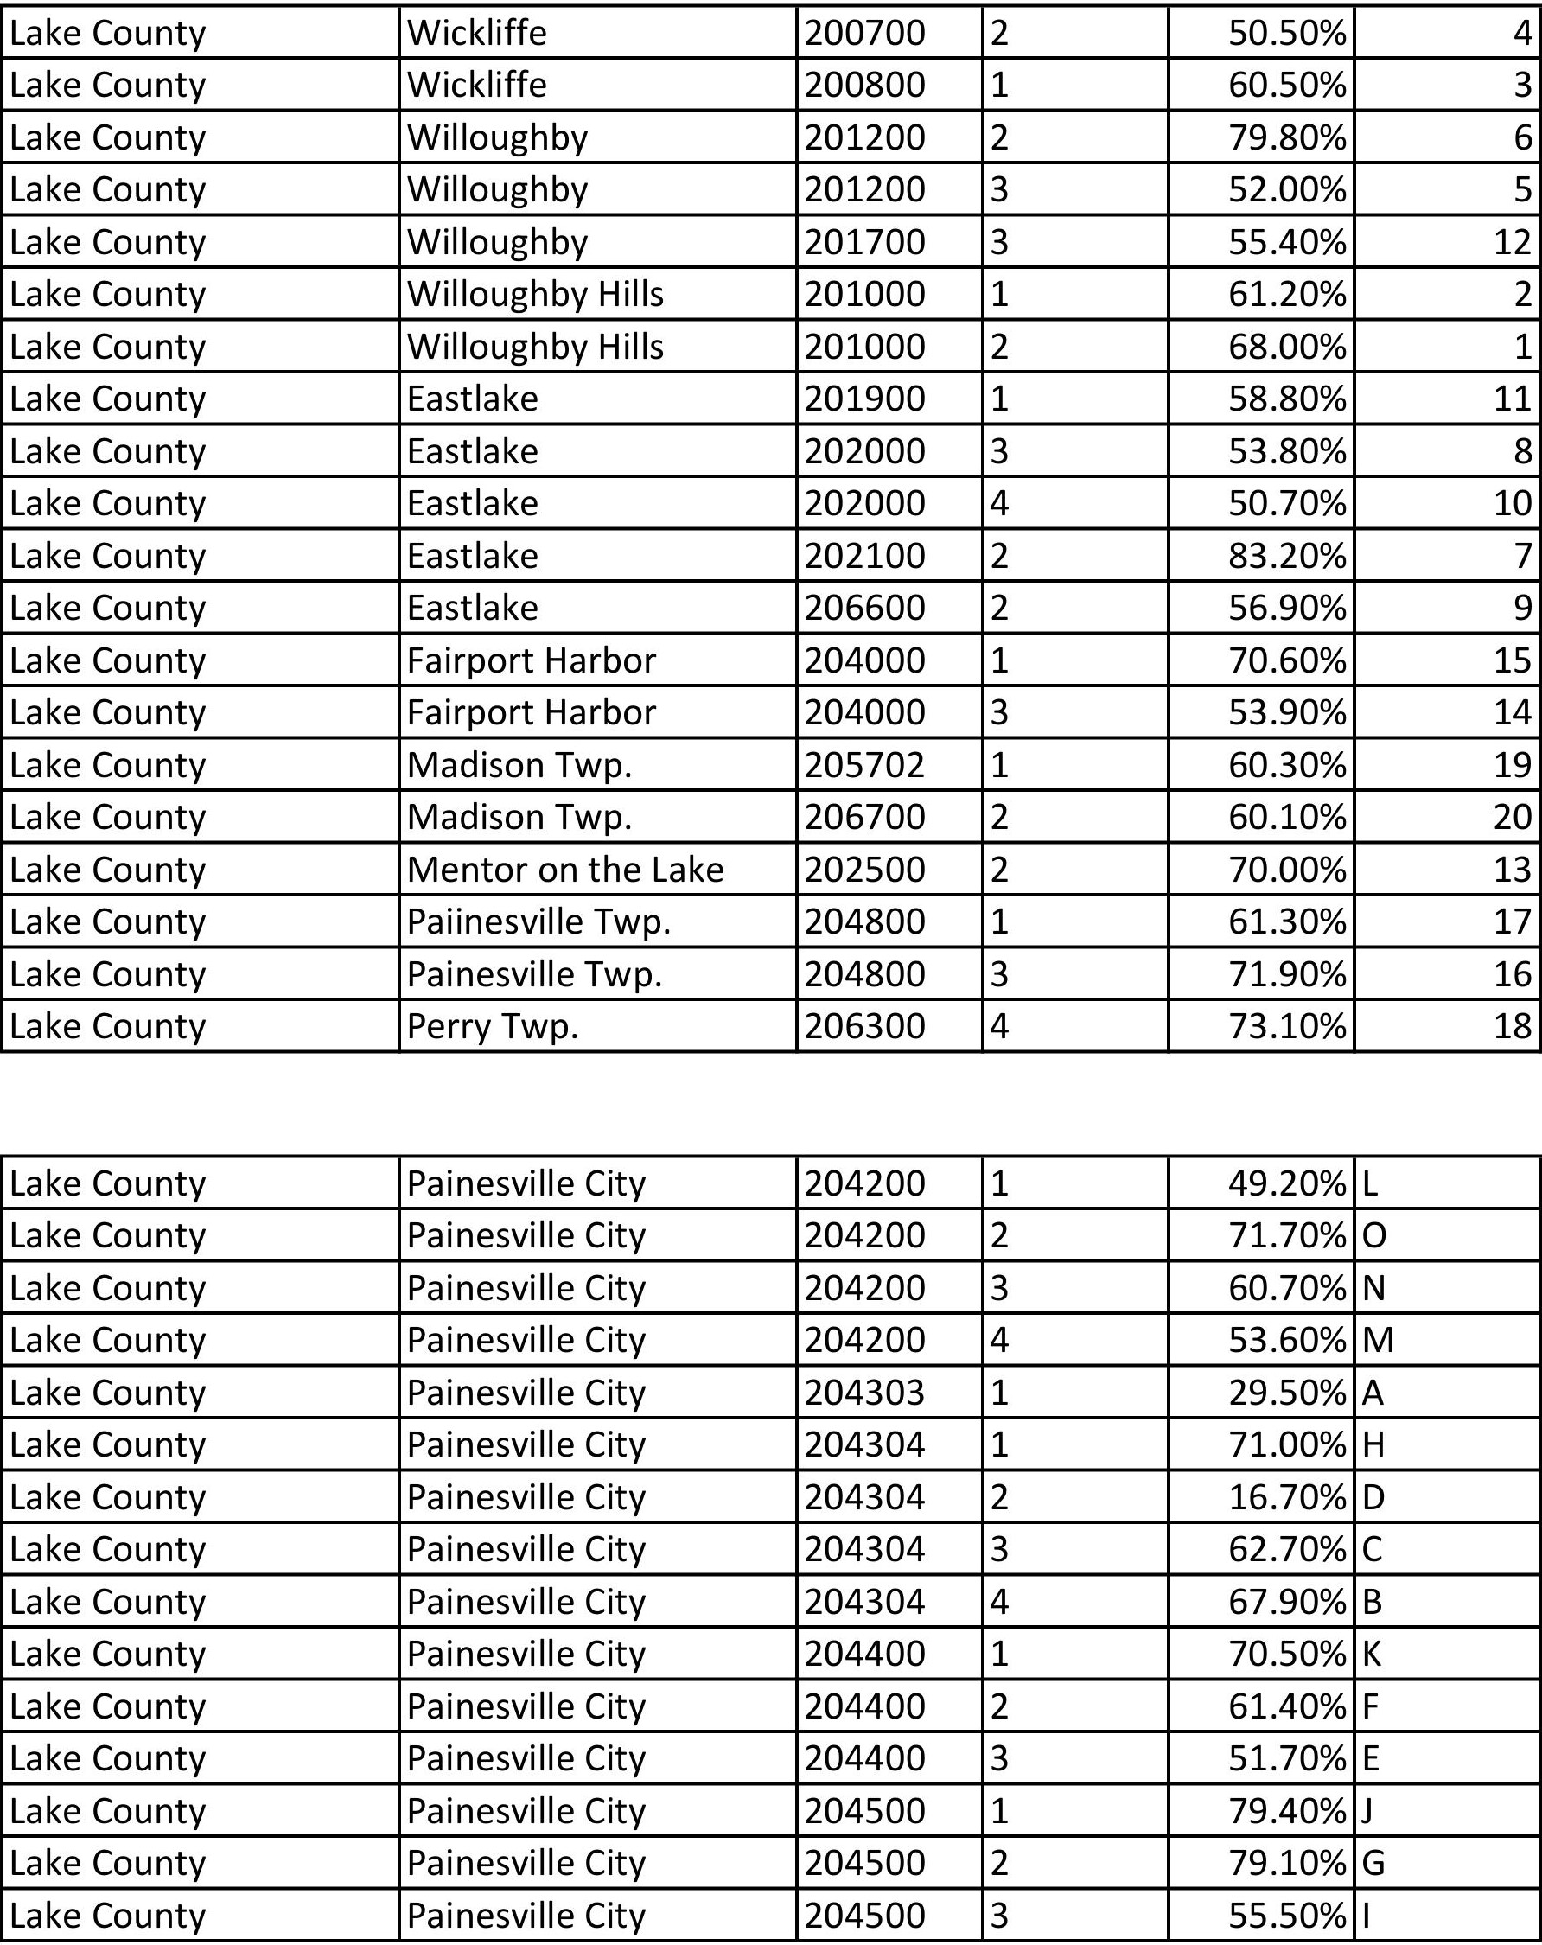
Appendix B - LOW INCOME BLOCK GROUP MAP

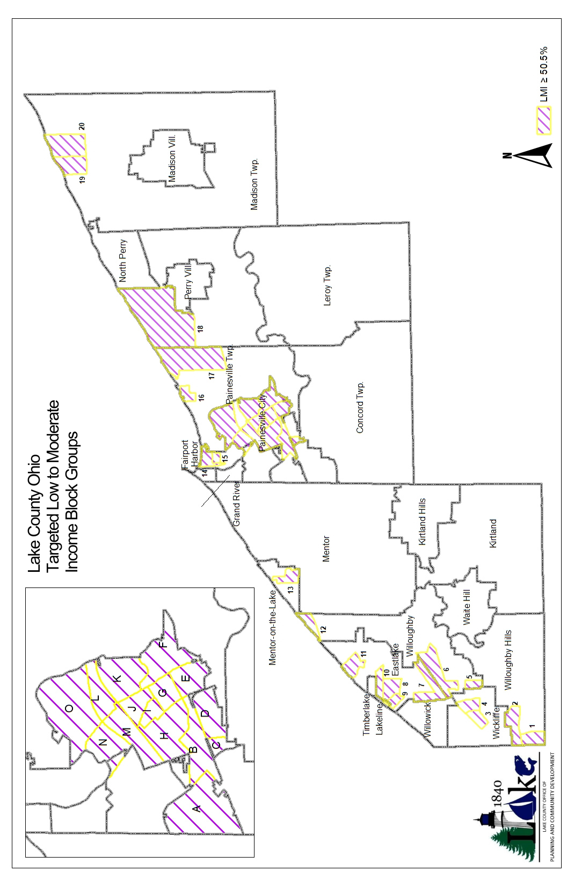

*More detailed maps of each municipality can be found on the Lake County Planning & Community Development website under “Community Development Forms,” then under subsection “Low-Income Block Group Maps.”
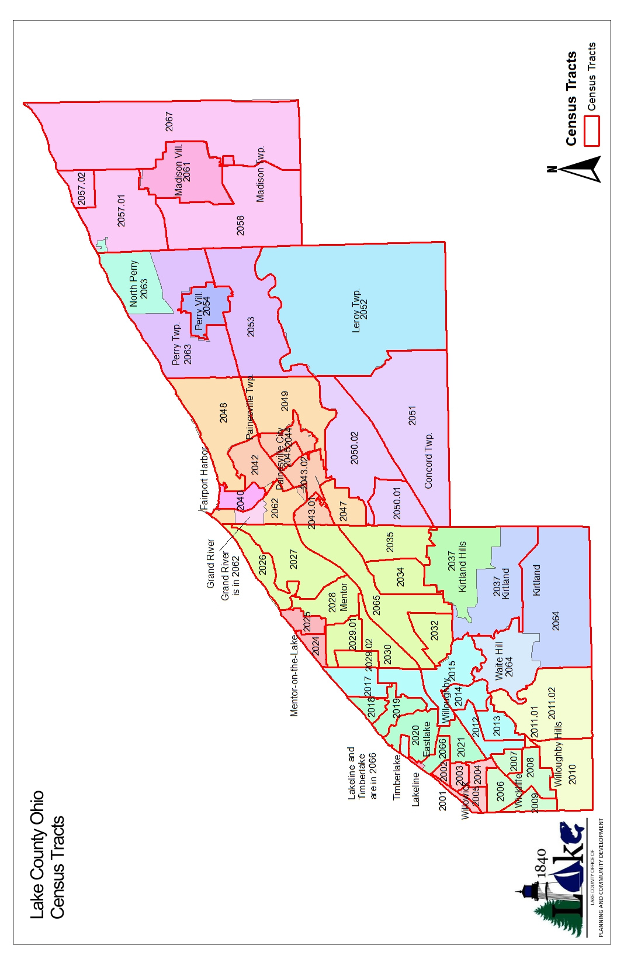
Appendix C - CENSUS TRACT MAP

Appendix D – AFFH AND CONSOLIDATED PLAN GOALS

In order to be eligible for CDBG and HOME funding in Lake County, applications must demonstrate that the proposed project or activity aligns with goals identified in the requisite HUD planning document: Consolidated Plan. Applicants are encouraged to become familiar with this document. Visit the LC Planning & Community Development website to view a copy of the Consolidated Plan. The applicant must affirmatively further fair housing and take any action that is rationally related to promoting one or more attributes of fair housing.

Applicants are required to undertake actions to affirmatively further fair housing (AFFH) in two ways.
- A fair housing resolution is required, as noted in the HOME application and page 6 of the CDBG application. This resolution is to be current. (6 months prior to or 1 month after) submitting CDBG or HOME application. A sample resolution with minimal accepted language can be found on the P&CD website.
- Select/describe/demonstrate actions to be taken that complete AFFH actions in the HOME application and Section VII of CDBG application.

CONSOLIDATED PLAN GOALS:

GENERAL PLAN GOALS

Safe and Decent Housing
Suitable Living Environment
Supportive Services
Assist Homeless and Special Needs Population
Regionally Coordinated Ec. Dev. Planning Strategy
Infrastructure Improvements

FAIR HOUSING TRAINING OPPORTUNITIES & RESOURCES:

Fair Housing Resource Center, Inc. (FHRC), Click here: https://fhrc.org/a-place-to-call-home-fighting-for-housing-equality-conference/, for the Fair Housing Conference on April 17th, 2025.

The National Fair Housing Alliance: View their website for videos and training events related to fair housing and posters available to be printed: https://nationalfairhousing.org/. Visit https://www.occd.org/upload/spring_2024/fair_housing_in_2024_and_beyond_occd_conference.pdf for a slideshow from the 2024 OCCD Conference.

Fair Housing Center for Rights & Research, https://www.thehousingcenter.org/ for online fair housing trainings, live education events, and publications. Visit https://thehousingcenter.org/wp-content/uploads/2025/01/Garfield-Heights-2025.pdf to learn more about the free seminar: Fair Housing Law Overview, on April 8th, 2025.

Ohio Development Services Agency, https://development.ohio.gov/individual/housing-and-homelessness/housing-and-homelessness for written fair housing resources.
Ohio Housing Finance Agency https://ohiohome.org/news/events.aspx OHFA trainings and events; Fair Housing Foundations course March 19th.
Coalition for Housing and Homelessness in Ohio COHHIO https://cohhio.org/housing-information/fair-housing/
Appendix E – SECTION 3 INFORMATION

Section 3 applies to: All projects/activities involving housing construction, demolition, rehabilitation, or other public construction—i.e., roads, sewers, community centers, etc. that are completed with covered funding are subject to the requirements of Section 3. Contractors or subcontractors that receive contracts in excess of $200,000 for Section 3 covered projects/activities noted above are required to comply with the Section 3 regulations.
The basis for Section 3 Requirements can be found at 24 CFR 75. Lake County, Ohio and HUD may monitor Subrecipients and contractors based on these requirements. The Section 3 program requires that recipients of certain HUD financial assistance, to the greatest extent possible, provide training, employment, contracting and other economic opportunities to low- and very low-income persons, especially recipients of government assistance for housing, and to business that provide economic opportunities to low- and very low-income persons. HUD Section 3 information can be found at https://www.hud.gov/section3
Visit the Lake County Planning & Community Development website, specifically the “Forms – HUD Section 3” page to become familiar with the Section 3 forms and requirements: https://www.lakecountyohio.gov/planning-community-development/section-3/
